Copyright for test papers and marking guides remains with *West Australian Test Papers.*

Test papers may only be reproduced within the purchasing school according to the advertised Conditions of Sale.

Test papers should be withdrawn after use and stored securely in the school until 4th December.



**SEMESTER TWO**

**MATHEMATICS**

**METHODS**

**UNITS 1 and 2**

**2020**

**SOLUTIONS**

**Calculator−free Solutions**

1. (a) 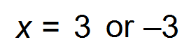 ✓✓

(b) 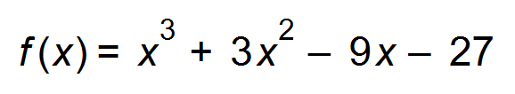

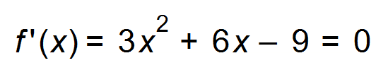 ✓

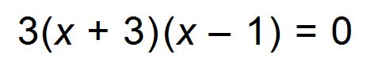

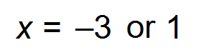 ✓

|  |  |  |  |  |  |
| --- | --- | --- | --- | --- | --- |
| *x* |  |  |  |  |  |
| *f*(*x*) | ↑ | - | ↓ | - | ↑ |
| *f ’*(*x*) | + | 0 | - | 0 | + |

✓

(- 3, 0) Maximum ✓

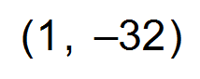 Minimum ✓

(c)  ✓ [8]

2. (a) 0 < *t* < 1 or 3 < *t* < 5 ✓✓

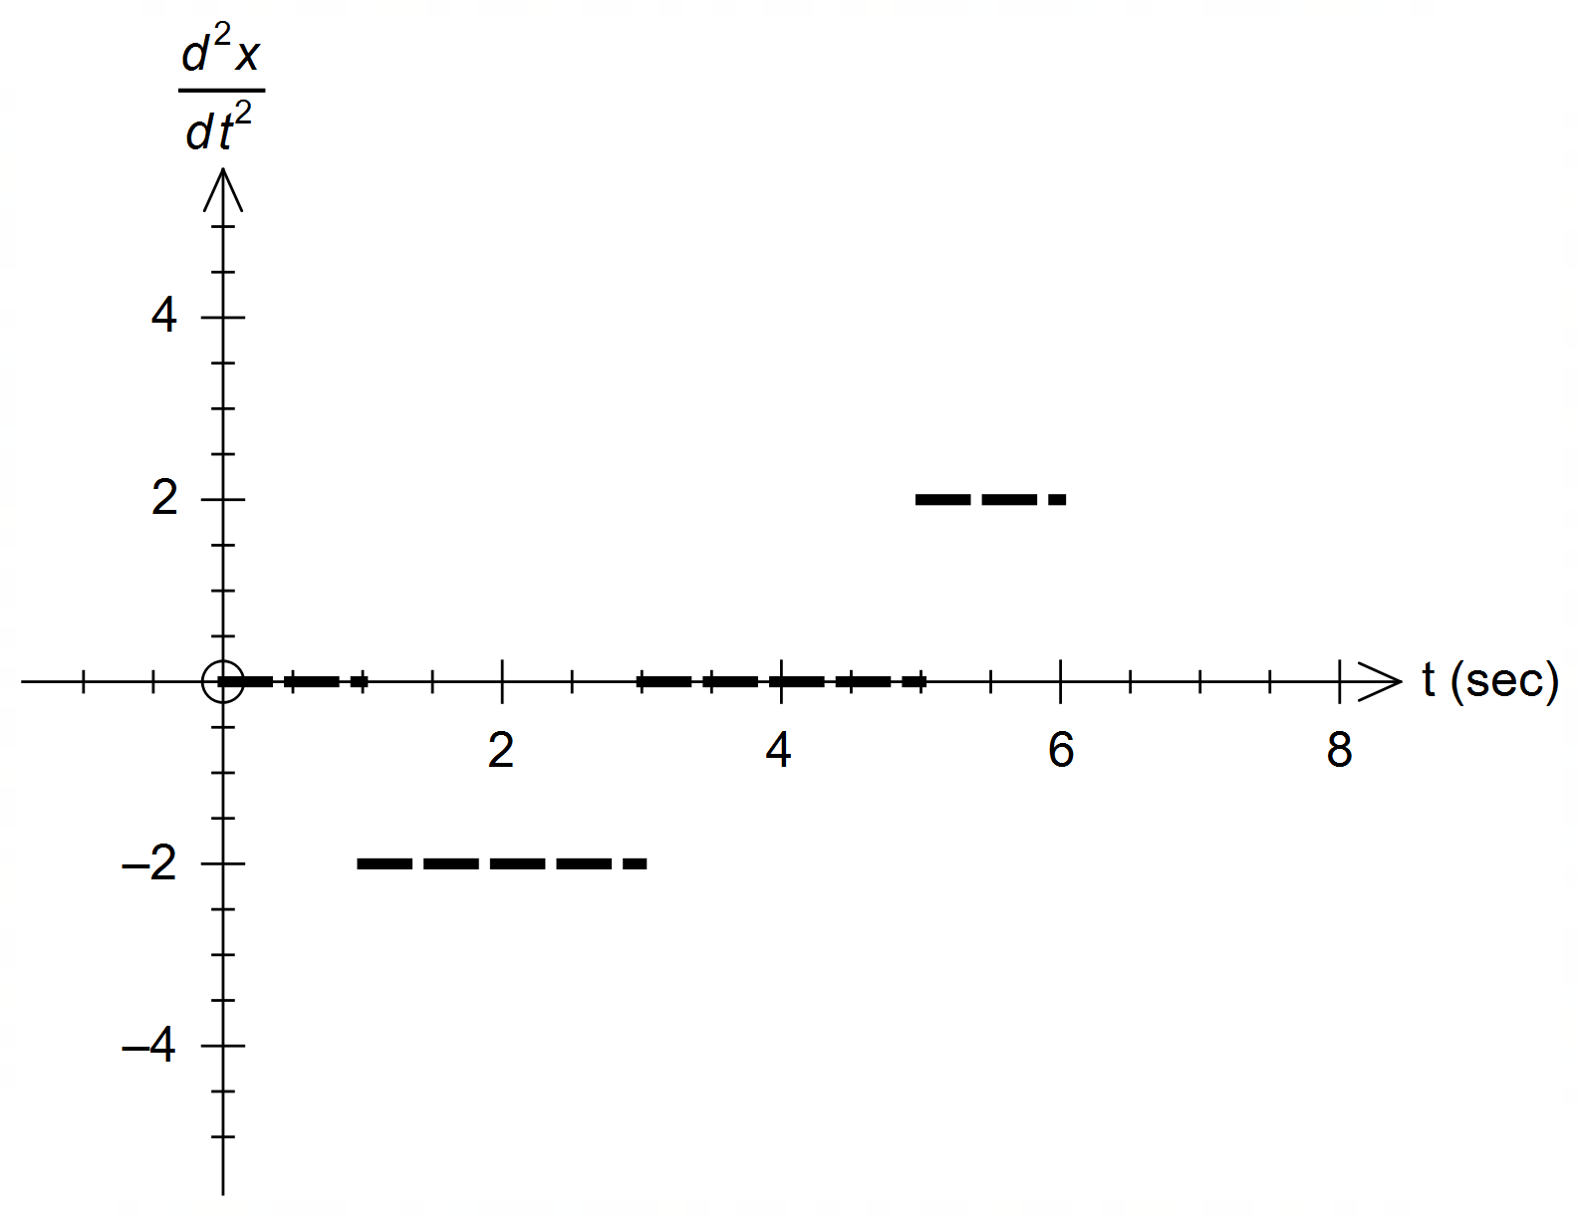 (b) 6 seconds (<0) 2 seconds (>0) ✓

(c)

✓✓ [5]

3. (a) (i) 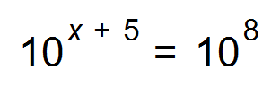

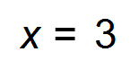 ✓

(ii) 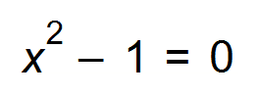 ✓

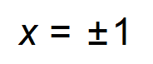 ✓

(b) 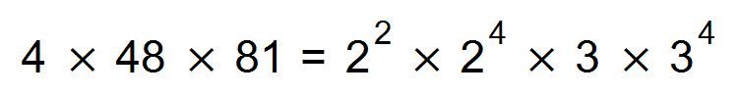 ✓

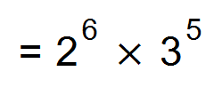

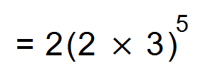 ✓

*k* = 5 ✓

(c) 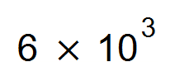 ✓✓ [8]

4. (a) 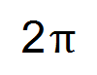 ✓

(b) 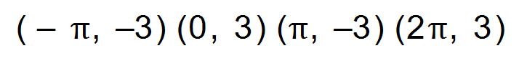 ✓✓

(c) 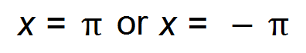 ✓

(d) 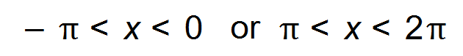 ✓✓ [6]

5. (a) 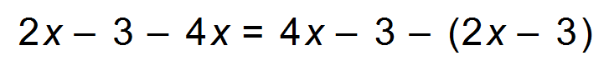 ✓

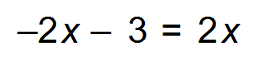

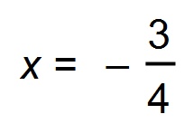 ✓

(b) 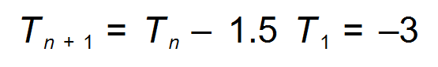 ✓✓ [4]

6. (a) 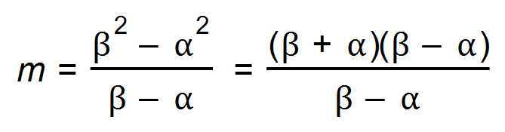 ✓✓

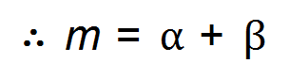

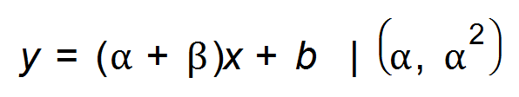 ✓

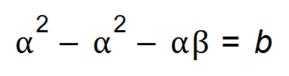 ✓

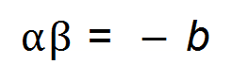

(b) (i) 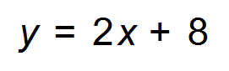 ✓

(ii) 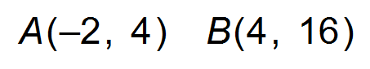 ✓

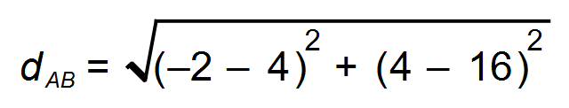

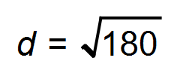 ✓

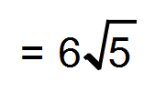 units

(iii) 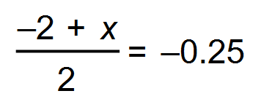

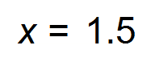 ✓

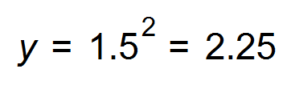 (or 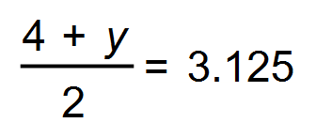 *y* = 2.25) ✓ [9]

|  |  |  |  |
| --- | --- | --- | --- |
|  | Location A | Location B | Totals |
| Buses left late | 15 | **40** | 55 |
| Buses left on time | **25** | 20 | **45** |
| Totals | 40 | **60** | 100 |

7. (a)

✓✓

(b) (i) The events are whether a bus leaves from Location A or not

and whether a bus left late or not. ✓

(ii) Probability of leaving from Location A = 0.4

Probability of leaving late = 0.55

P(Leaving from Location A and leaving late) = 0.15 ✓

0.4 x 0.55 = 0.22 and not 0.15, ✓

therefore the events are dependent. ✓

(iii) 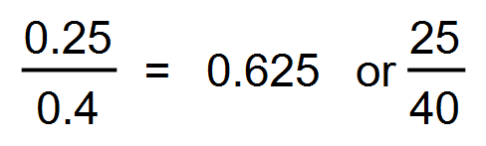 ✓

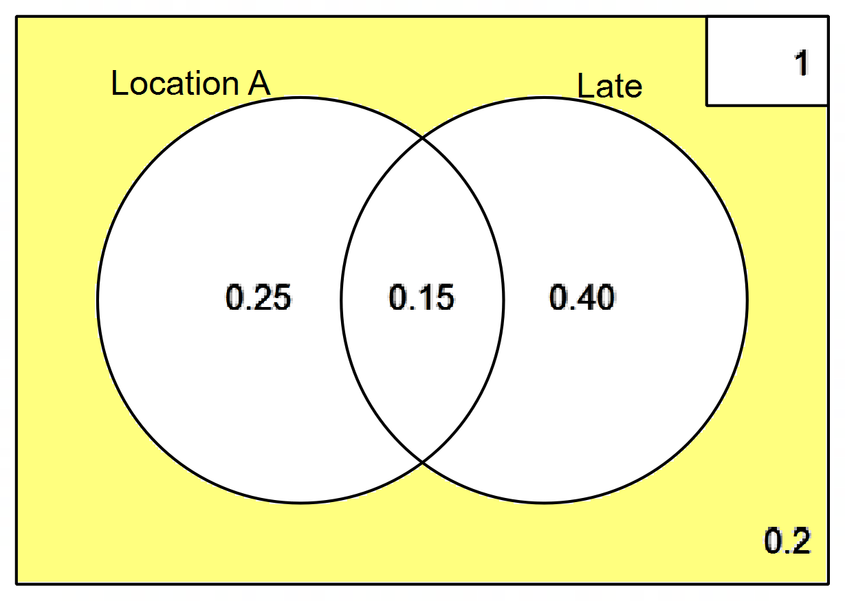

(c) (i)

✓✓

(ii) Shading ✓ [10]

**Calculator−assumed Solutions**

8. (a) 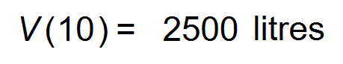 ✓

(b) 60 mins ✓

(c) 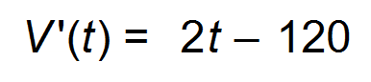 ✓

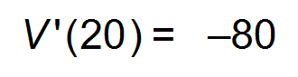litres per minute ✓

(d) 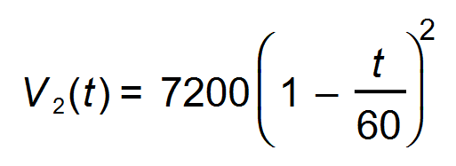

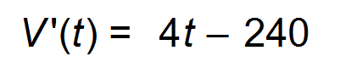 ✓

This is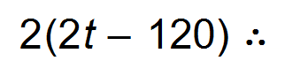double the rate ✓ [6]

9. (a) 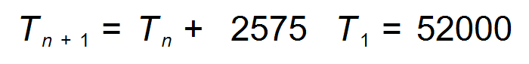 ✓✓

(b) 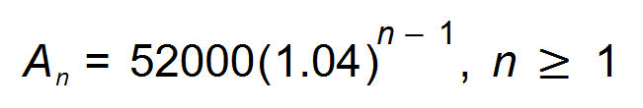 ✓✓

(c) $74 012.21 ✓

(d) During the 13th year (83253>82900) ✓✓

(e) Skye: $1 548 460. 09 ✓

Indy: $1 529 250.00 ✓

Skye’s total earnings exceeds Indy’s total earnings

by $19 210.09 ✓ [10]

10. (a) 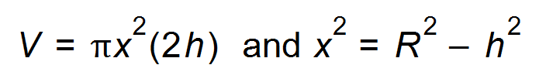 ✓✓

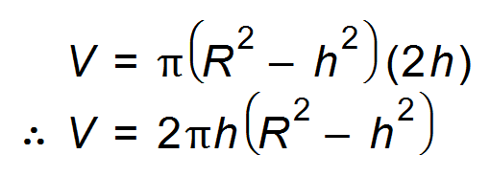 ✓

(b) 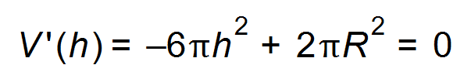 (for max/min) ✓

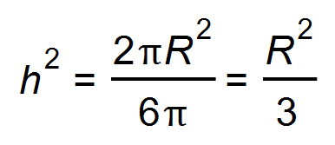 ✓

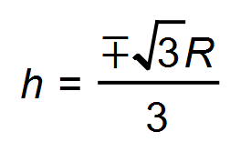 Discard negative *h*

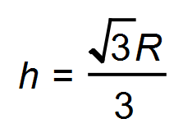 ✓ [6]

11. (a) 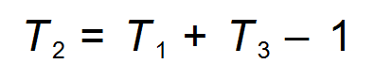 ✓

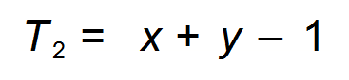

(b) 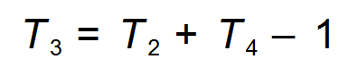

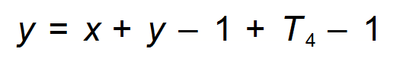 ✓

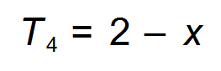 ✓

Sum =  ✓

(c) No common difference nor common ratio ✓✓ [6]

12. (a) F ✓

(b) F ✓

(c) F ✓

(d) T ✓

(e) F ✓ [5]

13. (a) 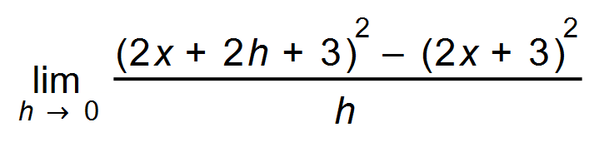 ✓✓

(b) 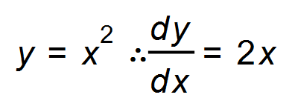 when *x* = 3 ✓

2(3) = 6 ✓

(c) 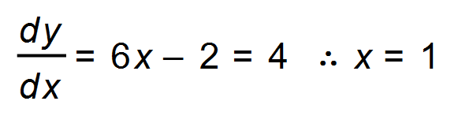 ✓

*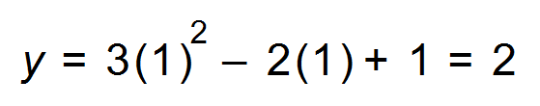 y* = 2 ✓

(d) 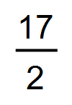 ✓ [7]

14. (a) 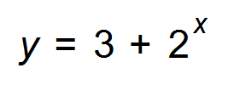D ✓

(b) 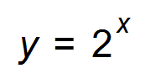 C ✓

(c) 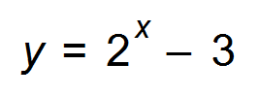 A ✓

(d) 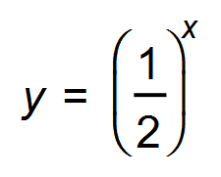 B ✓ [4]

15. (a) 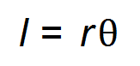

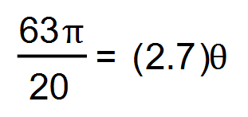 ✓

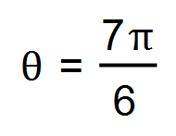 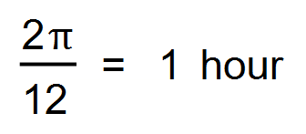  this has taken 7 hours. ✓✓

(b) 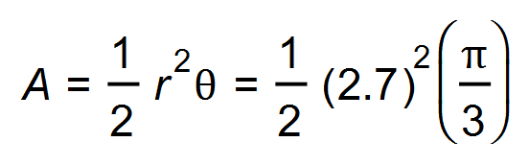 ✓

= 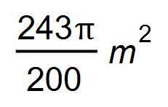 ✓ [5]

16. (a) 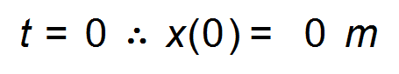 ✓

(b) 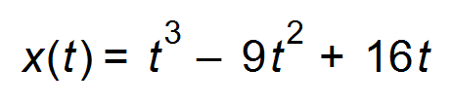

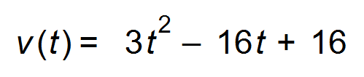 ✓

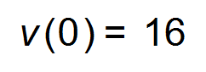 m/s ✓

The particle is initially travelling to the right of the origin. ✓

(c) 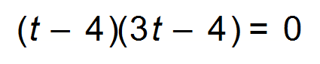

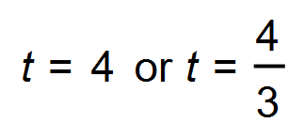 First changes direction at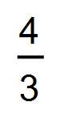s. ✓

(d) 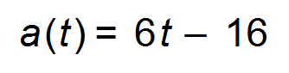 ✓

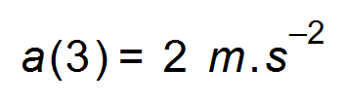 ✓

(e) 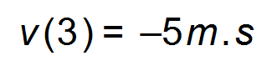 ✓

Velocity is negative and acceleration is positive therefore the particle is slowing down. ✓

(f) First turns at s. 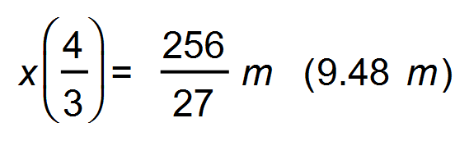 ✓

Turns again at 4 s. 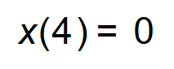 ✓

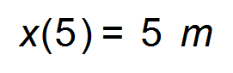

Total distance = 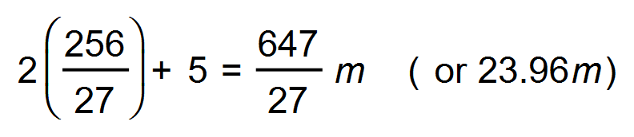 ✓ [12]

17. (a) 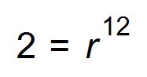

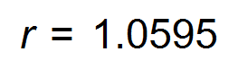 ✓

 5.95% per hour is the rate of growth

(b) 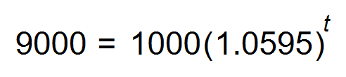 ✓

t = 38.016

Approximately 38 hours. ✓

(c) 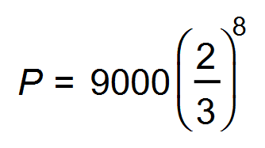 ✓

*P* = 351 bacteria left ✓

Their expectations were not accurate. The anti-biotic killed more

than a third of the bacteria per hour. ✓

**OR**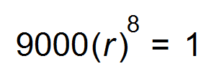

*r* = 0. 3204 The antibiotic killed 68% per hour which is more than 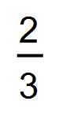. [6]

18. (a) (i) 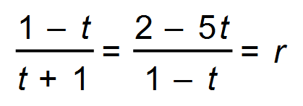 ✓

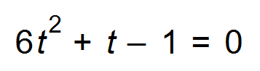

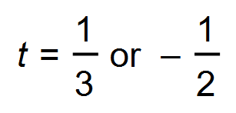 ✓

For 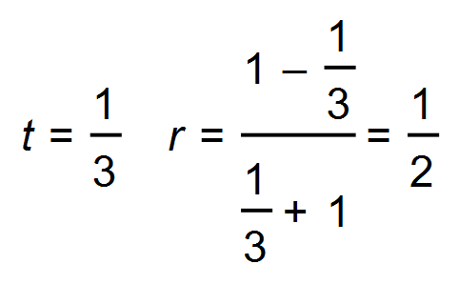 ✓

For 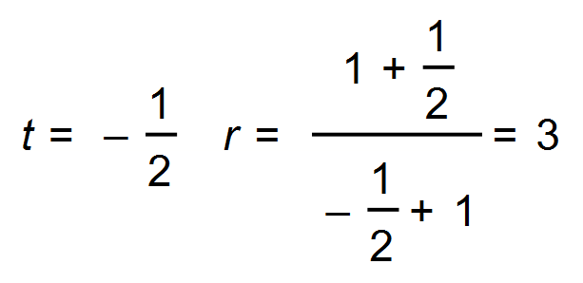 Discard ✓

Common ratio = 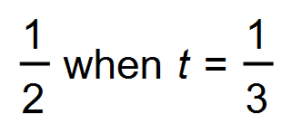

(ii) 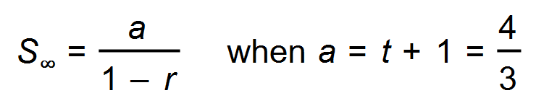 ✓

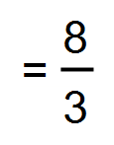 ✓

(b) (i) 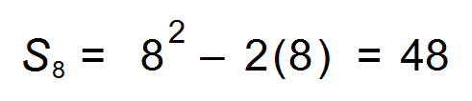 ✓

(ii) 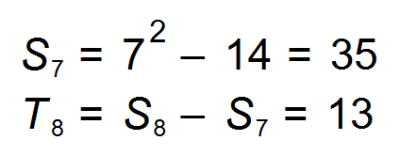 ✓✓

(iii) 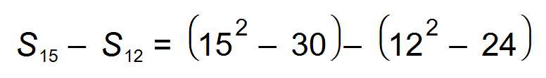 ✓

= 75 ✓

(c) 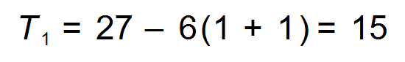

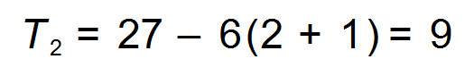

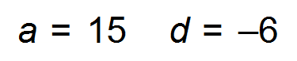 ✓✓

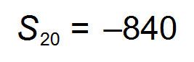 ✓ [14]

19. (a) Roots at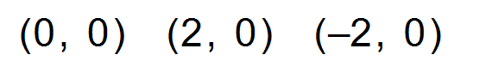 ✓

(b) 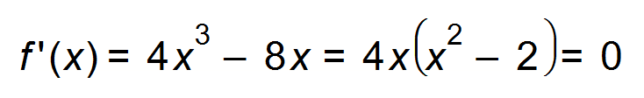(for stationary points) ✓

Stationary points at 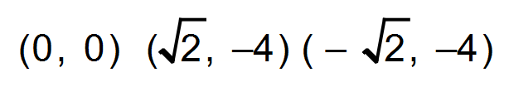 ✓

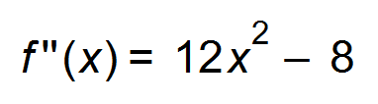 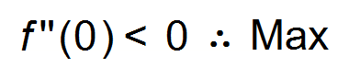 ✓

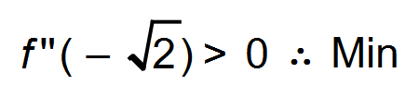 ✓

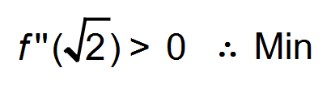 ✓

Or Sign table:

|  |  |  |  |  |  |  |  |
| --- | --- | --- | --- | --- | --- | --- | --- |
| *x* |  |  |  | 0 |  |  |  |
| f(*x*) | ↓ |  | ↑ |  | ↓ |  | ↑ |
| f’(*x*) | - | 0  Min | + | 0  Max | - | 0  Min | + |

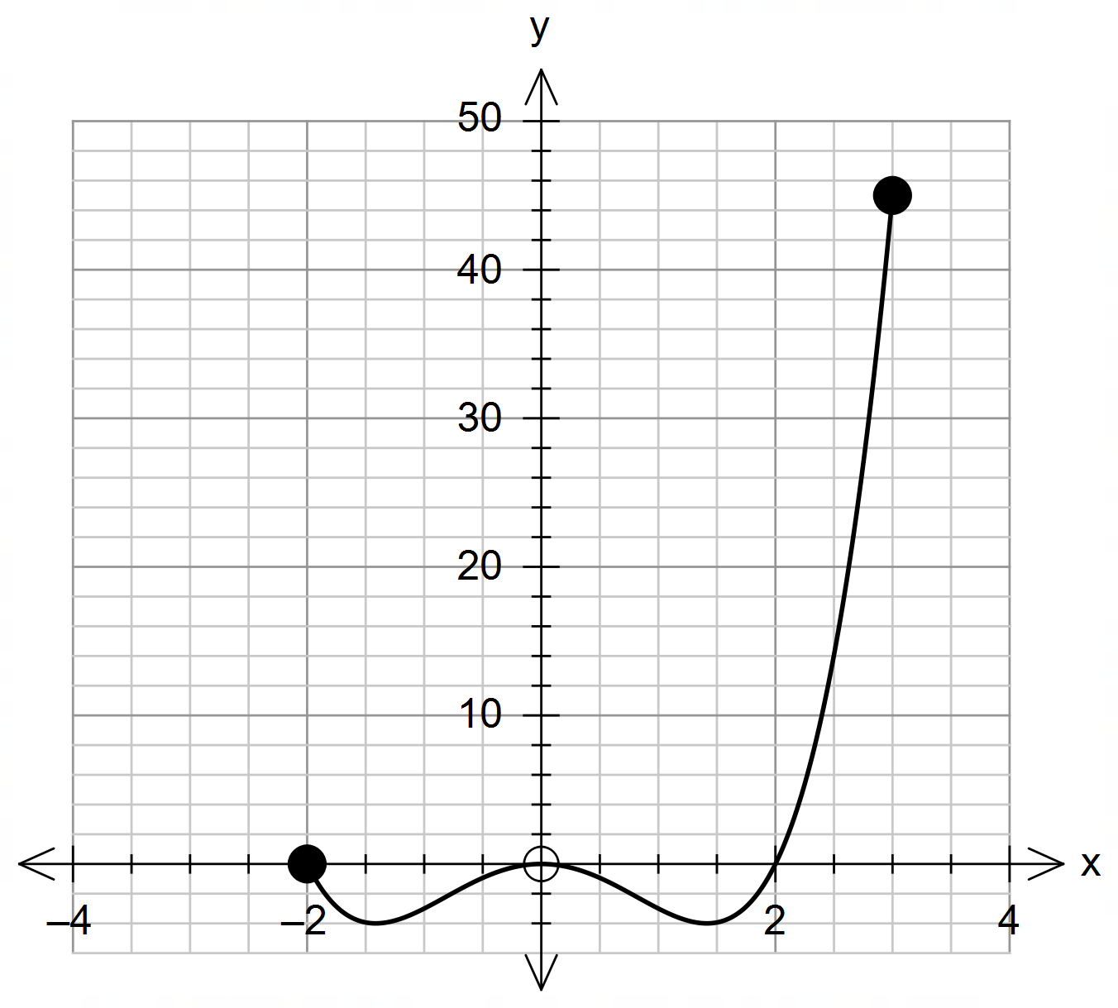 (c)

✓✓✓ [9]

20. (a) (i) 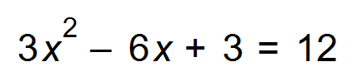

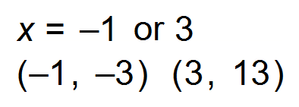 ✓✓

(ii) 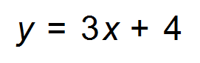 *m* = 3

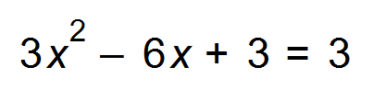

*x* = 0 or *x* = 2

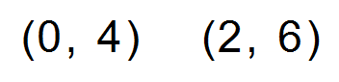 ✓✓

(iii) 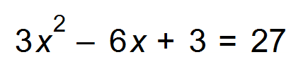

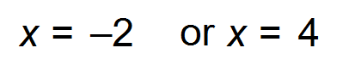

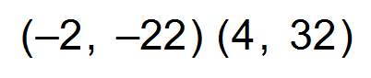 ✓✓

(b) 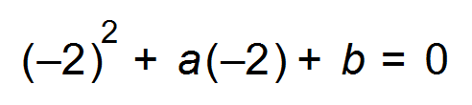

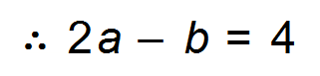

And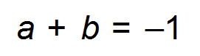

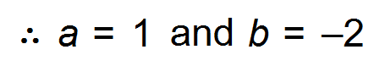 ✓✓

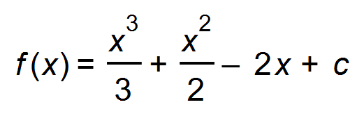 | (2, 3) ✓

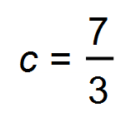 The equation of the curve is 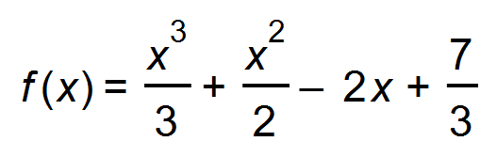. ✓ [10]

End of Questions